ZeroWaste

Members: Alvaro Z. Maldonado, Favio Maximo G. Alfonso, Alysza Mae T. Balansag

**PROJECT DESCRIPTION**  
The goal of this project is to create an intuitive application that will assist users in avoiding distractions when completing tasks or working on a job. Designed with a range of user demographics in mind, including professionals and students, the software provides easy-to-use tools for cutting down on distractions including social media, friend messaging, and entertainment. Time-wasting is minimized and productivity is maximized with the app's adjustable features and streamlined layout.

**REQUIREMENTS SUMMARY**

We have to ensure the app:

* Is easy for the users to understand and utilize.
* Provides a clean interface to lessen user error.
* Locks apps by blocking their notifications and usage.
* Can cancel app locking early based on user input.
* Notifies the user when the timer is completed.
* Can work on multiple mobile devices.

**PROTOTYPE**

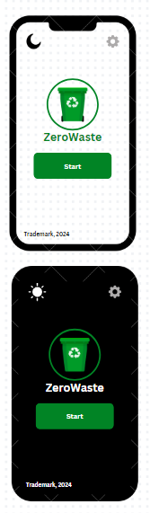

***Figure 1***

***Figure 1*** shows the draft homescreen of ZeroWaste. It provides the user with a simple start button to get the app to work, and there is the settings button at the top right. The application can also be customized in terms of theme, light and dark. All assets in this screenshot are the first ideas that we came up with as a group. (Logo was not finalized at the time).

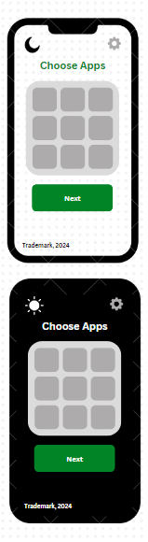

***Figure 1.2***

***Figure 1.2*** shows what happens once “START” is pressed. The user will be given this GUI, where they can choose any apps that they want to lock/disable to focus on work/studies. Once again, the settings button is on the top right and the app can be used in light or dark mode.

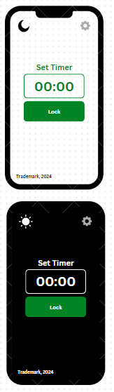

***Figure 1.3***

***Figure 1.3*** shows the screen in which the user can select the amount of time that the selected applications can be locked for, this is completely up to the user as to how long they want the time to be set. Settings are on the top right, and the light and dark theme feature remains on the top left.

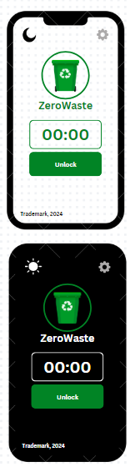

***Figure 1.4***

***Figure 1.4*** shows the screen in which the time is fully selected and the timer is now ticking down until finished. The user is given the option to manually unlock the apps in case where there was an error in inputting the timer, or where they accidentally selected an app.

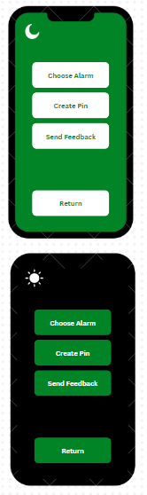

***Figure 1.5***

***Figure 1.5*** shows what the settings screen would look like, there are 4 simple buttons with their own individual functions; Choose Alarm for choosing what alarm sound the user may want played once the timer is done (The sound can be a custom one, or a default one that comes with the phone already). The Create Pin button is designed so that the user can input a PIN when opening the application, by entering the pin, this unlocks full access to the application. The Send Feedback button allows the user to send direct and honest feedback to the developers of the application to give their own insights on the application, whether it's positive or negative feedback, this allows the developers to know what’s right and wrong and what to take into consideration. The Return button is to simply allow the user to go back to the main screen.

**REQUIREMENT CHANGES**While creating ZeroWaste, we became aware of how crucial it was to make sure the program worked properly offline. Based on comments from users who viewed the app, we concentrated on keeping the UI straightforward and easy to use. They helped shape these changes by letting us know what they liked and didn't like.